


Experiment No.: 4

Title

Crypt Arithmetic Problem using Python

Aim

To solve the Crypt Arithmetic Problem using Python.

Apparatus / Software Required

Computer or Laptop

Python 3.x

IDLE / VS Code / PyCharm (Any Python IDE)

Windows Operating System

Procedure

Open the Python IDE.

Create a new Python file.

Write the Python program for the Crypt Arithmetic Problem.

Save the file with the .py extension.

Run the program.

The program assigns unique digits to each letter.

It checks all possible combinations.

Display the correct solution that satisfies the equation.

Verify the output.

Close the program.

Program
from itertools import permutations

letters = ('S','E','N','D','M','O','R','Y')

for p in permutations(range(10),8):

d = dict(zip(letters,p))

if d['S']==0 or d['M']==0:

continue

send = d['S']*1000+d['E']*100+d['N']*10+d['D']

more = d['M']*1000+d['O']*100+d['R']*10+d['E']

money = d['M']*10000+d['O']*1000+d['N']*100+d['E']*10+d['Y']

if send + more == money:

print(d)

break

Sample Output
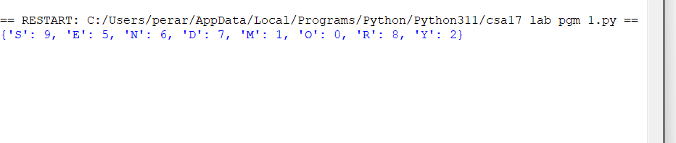

Result

Thus, the Python program to solve the Crypt Arithmetic Problem was implemented successfully, and the correct digit assignment satisfying the equation was obtained.

